**Self-review: Create a navigation in Compose**

1. In this exercise, which property of the **NavHost** is used to set the initial destination?

1. **modifier**
2. **navController**
3. **startDestination**

2. In this exercise, the composable function is used to add the routes for the for the **NavHost**.

1. True
2. False

3. In this exercise, which one of the following variables are created in the Destinations interface for defining the **NavGraph**.

1. route
2. nodes
3. icon

1-c 2-a 3-a

# Self-review: Create tabbed navigation with JetPack

1. In the exercise, which property of the Scaffold do you use to add **MyBottomNavigation**?

1. **modifier**
2. **bottomBar**
3. **topBar**

2. In this exercise, which properties do you set for the **BottomNavigationItem**. Select all that apply.

1. Selected
2. onClick
3. label
4. icon

3. In the exercise, which one of the following approaches is used to iterate the list with an index?

1. **forEachIndexed** method
2. **forEach** method

1-b 2-a,b,c,d 3-a

# Knowledge check: JetPack Navigation

1. Which among the following actions can start navigation? Select all that apply.
2. Clicking a button
3. Selecting an item from the list
4. Clicking a tab item

2. Bottom Navigation only navigates to a new destination without showing the status of the active item.

1. True
2. False

3. Select all that apply. The fixed start navigation principle states that:

1. The application always ends with the same starting screen while leaving the app.
2. The application always starts from the same first screen.
3. The application always starts from the same screen but ends with a different screen.

4. The Stack works on which one of the following principles?

1. Last in First out
2. First in Last out
3. First in First out
4. Last in Last out

5. Select all that apply.

The purpose of **NavHost** is to:

1. take the **NavController** as a parameter and associate it with the **NavGraph**.
2. act as a container for displaying the current destination.
3. manage the Back Stack.

1-a,b,c 2-b 3-a,b 4-a 5-a,b

# Self-review: Create a scrollable gallery

1. In this exercise, which function did you call to make the Column Scrollable?

1. **Modifier.imeNestedScroll()**
2. **Modifier.verticallScroll()**
3. **Modifier.horizontalScroll()**

2. In this exercise, which property is used for arranging Row items?

1. **horizontalArrangement**
2. **verticalArrangement**

3. In this exercise, which one of the following approaches was used to populate the Grid?

1. **forEachIndexed** method
2. **repeat** method
3. **forEach** method

1-b 2-a 3-b

# Knowledge check: Lists and Grids

1. Which among the following can be used to place its children horizontally?

1. Column
2. Row

2. Which one of the following arrangements adds space to the first and last child on the list while keeping other items in the center?

1. Space between
2. Space around
3. Space Evenly

3. Which of the following arrangements can be used with a Column?

1. Horizontal Arrangement
2. Vertical Arrangement
3. Both Vertical and Horizontal Arrangements

4. Scrolling is available to a Row and a Column without adding any modifier.

1. True
2. False

5. For creating a Grid of a small number of elements, a combination of Row and Column composable can be used.

1. True
2. False

1-b 2-b 3-b 4-b 5-a

# Self-review: Create and style a lazy grid

1. In this exercise, which of the following parameter was passed to **GridCells.Adaptive()**?

1. 140.dp as the minimum size
2. 140.sp as the minimum size
3. 2as the count of columns

2. In this exercise, **GridCells.Fixed()** defines a grid with as many rows or columns as possible.

1. True
2. False

3. In this exercise, which one of the following approaches is used to populate the **LazyVerticalGrid**? Select all that apply.

1. forEach
2. **forEachIndexed** method
3. **items** method

**1-a 2-b 3-b,c**

# Advanced UI with JetPack Compose

1. Which of the following are required to add navigation between multiple screens? Select all that apply.

1. **NavController**
2. **NavGraph**
3. **RouteController**
4. **NavHost**

2. Which of the following must each **NavHost** be associated with?

1. A **route**.
2. A single **NavController**.
3. A destination.
4. The **NavGraph**.

3. Which of the following is the correct way to create a destination object for a Profile screen that implements the below **Destinations** interface?

a)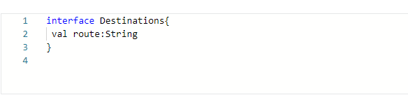

b)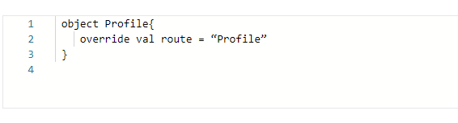

c)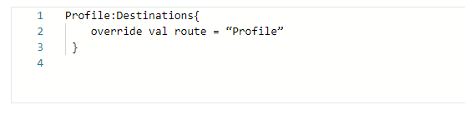

d)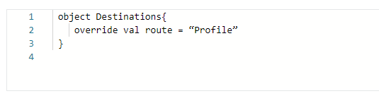

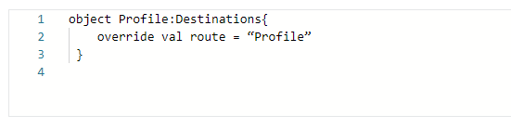

4. Which of the following is the default argument type for the **navArgument()** function?

1. **String**
2. **Int**
3. **Boolean**

5. In Jetpack Compose Navigation, the __________ function is used for constructing a new argument.

1. **argument()**
2. **navArgument()**
3. **argumentNav()**

6. What is each bottom navigation element called?

1. **bottomNavigationItem**
2. **navigationItem**
3. **bottomNavItem**

7. Which of the following is used for a vertical list of an unknown number of items?

1. **Column**
2. **LazyColumn**
3. **LazyRow**

8. Which of the following composes only that which is in the visible viewport? Select all that apply.

1. **LazyGrid**
2. **LazyColumn**
3. **LazyVerticalGrid**
4. **LazyRow**

9. Which among the following are the parameters of the composable function defined in the **NavHost**? Select all that apply.

**route**

1. **startDestination**
2. **navController**
3. **arguments**

10. ________ is a collection of navigable destinations.

1. **NavGraph**
2. **NavController**
3. **NavHost**

1-a,b,d 2-b 3-d 4-a 5-b 6-a 7-b 8-b,d 9-a 10-a